Elias Thorne:
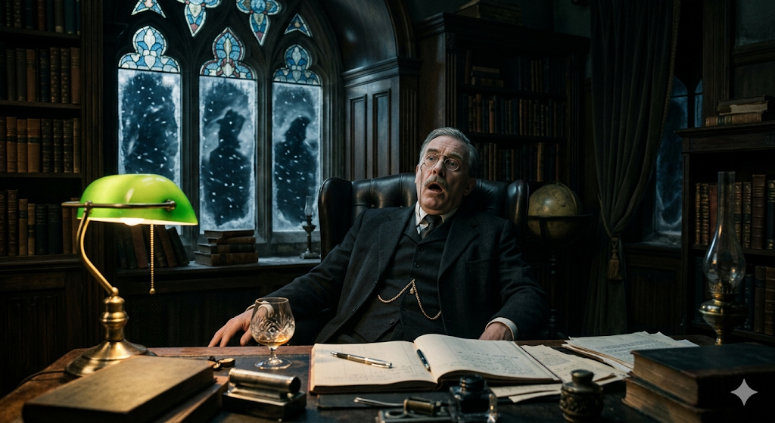
When the door to Thorne’s study is opened, the first thing visible is the stillness.
The room is dimly lit by a single green-shaded desk lamp, casting a cone of yellow light across the oak desk. Outside the tall stained-glass windows the blizzard roars, but inside the air is unnaturally quiet.
At the center of the room sits Elias Thorne.

Position of the Body
Thorne is seated in a high-backed leather chair behind his desk.
His posture is unnatural:
- His back is rigid against the chair.
- His head has tilted slightly backward.
- His shoulders appear locked in place, as if his body froze mid-motion.
One arm rests on the armrest.
The other lies half-raised on the desk, fingers slightly curled toward the brandy glass.
It looks as though he tried to stand — and never finished the movement.

Facial Expression
Thorne’s face carries the unmistakable look of sudden shock.
- His eyes are open, glassy and unfocused.
- His brows are drawn upward, frozen in alarm.
- His mouth is slightly open, as if he had begun to gasp.
There is no blood. No wound.
But the expression suggests he understood something was terribly wrong in the final seconds.

Physical Signs of Poisoning (Aconite)
The effects of aconite poisoning are subtle but disturbing.
Observations visible to the player:
- His skin has a faint gray pallor, especially around the lips.
- The tips of his fingers appear slightly bluish from cardiac arrest.
- There is a light sheen of sweat across his forehead.
- A faint bitter herbal smell lingers near the brandy glass.
His body appears stiff earlier than expected — a sign the heart stopped suddenly.

Clothing
Thorne is dressed as he would be every evening:
- Dark wool three-piece suit
- Gold watch chain across his vest
- White shirt with slightly loosened collar
- Spectacles have slipped halfway down his nose
One shoe is angled outward, as though he pushed his chair back abruptly.

Immediate Objects Around the Body
These objects reinforce the moment of death:
On the Desk
- Half-empty brandy glass
- Heavy crystal decanter
- Open ledger book
- Ink pen knocked slightly sideways
On the Sideboard
- Brandy tray
- Service log clipboard
Behind the Chair
- The chair legs have shifted a few inches, implying a sudden movement.

Environmental Details
Level designers can use subtle elements to make the scene feel real:
- The desk lamp flickers occasionally.
- Frost forms along the edges of the window.
- Wind whistles faintly through the chimney.
- The clock on the wall ticks loudly in the silence.
The overall impression is clear:
Thorne did not struggle.
He realized he was dying, tried to rise from his chair — and collapsed before he could call for help.

The Shimla Ledger — Storyline
Premise
In the winter of 1926, the Viceregal Library of Shimla becomes the scene of a locked-room murder when a violent blizzard isolates everyone inside.
The telegraph lines are cut at 18:00, trapping the remaining occupants in the building for the night.
Hours later, Elias Thorne, the rigid and rule-obsessed chief librarian, is found dead in his office—killed by aconite poison hidden in his nightly brandy.
With no way in or out of the building, the killer must be one of the three people still inside the library.

The Victim
Elias Thorne
Thorne was a meticulous and uncompromising English administrator who believed in strict order and accountability.
He ran the library like a ledger:
- Every book cataloged
- Every rupee accounted for
- Every scholar watched closely
On the night of the storm, Thorne uncovered three separate betrayals, giving each suspect a powerful motive.

The Suspects
Mrs. Eleanor Graves — The Steward
Graves has managed the administrative affairs of the library for fifteen years and is known for her polite and maternal demeanor.
However, Thorne discovered that she had been embezzling money through falsified “Ghost Coal” shipments, quietly diverting thousands of rupees from the library budget.
If exposed, she would lose her reputation and possibly face prison.

Dr. Arthur Bell — The Scholar
Dr. Bell is an Oxford-educated botanist studying Himalayan plants.
Behind his academic reputation lies a secret: much of his work is plagiarized from local herbal knowledge, passed off as his own discoveries.
Thorne had uncovered evidence proving Bell’s research was fraudulent.
If revealed, Bell’s career would be destroyed.

Arjun Singh — The Archivist
Arjun Singh is the quiet archivist responsible for the library’s historical manuscripts.
Thorne discovered that a document tied to Singh’s family lineage contained a forged historical claim, one that would disgrace Singh’s ancestors if exposed.
In desperation, Singh secretly removed Page 42 from the manuscript to hide the truth.

The Night of the Murder
The evening unfolds under the pressure of the storm.
At 19:25, Thorne’s nightly brandy is poured and placed in his office.
Between 19:30 and 20:30, each suspect visits Thorne individually, attempting to persuade him not to reveal their secret.
During this time, someone secretly retrieves aconite tincture from a crate in the storage room
The poison is slipped into Thorne’s drink.
At 20:42, Thorne takes a sip of the brandy and dies almost instantly from cardiac arrest.

The Investigation
The player takes the role of the investigating detective.
Because the storm has sealed the building, the investigation must rely entirely on:
- Interrogating the suspects
- Searching the rooms of the library
- Uncovering hidden evidence
As the investigation progresses, each suspect’s secret is revealed:
- Graves’ embezzlement
- Bell’s academic fraud
- Singh’s theft of the manuscript page
Each revelation deepens the mystery but does not immediately reveal the killer.

The Final Puzzle
The key to solving the murder lies in connecting three elements:
- Motive – Which suspect had the strongest reason to silence Thorne?
- Opportunity – Who had access to the office and the poisoned drink?
- Means – Where was the missing vial of aconite hidden?
The murder weapon—the empty poison vial—can be discovered in a location tied to the true killer.

The Ending
When the player correctly identifies the killer and presents the evidence, the suspect’s composure finally breaks.
Their confession reveals that Thorne’s rigid pursuit of truth forced them into a desperate act.
The storm eventually clears, and the police arrive.
But the investigation leaves one unsettling realization:
Elias Thorne believed every secret could be written into a ledger and judged by rules.
Yet in the quiet halls of the Viceregal Library, human desperation proved far more dangerous than any poison.

The main storyline is that all 3 people in the library that night had motives to kill the librarian. The game decides initially which one of the three to choose as killer and then accordingly we give them prompts to behave.
The library contains a pantry, a storage room, a staff room, main reading hall with rows and columns of books and many benches, the main reading hall has a corridor that leads to the storage room pantry the staff room and the office of our victim
Elais thorne is found dead with a half drunk glass of brandy with the distinct smell of local Himalayan poison. His table contains many books in which one was open but had a torn page 42, it was an old manuscript. Beside this book there is also the financial record and ledger of the library.

Arjun Singh is one of the suspects, Arjun is nationalist, patriotic and filled with enthusiasm for his country and cites historical events for his defence. He talks about the law of karma and other Indian core philosophies to defend himself. he claims that he was studying a sanscrit manuscript that evening and when he went to submit the report to Elias Thorne he found him dead, Arjun claims that he has no knowledge of the torn page and saw that after the detective pointed it out. Arjun is a nationalist hence Thorne and Dr bell despice him while he has the sympathy of the stewardess. Arjun comes from the noble family of Shimla. Arjun is the one who reports the body at 10pm after going into the room to return an archive which he took from thorne’s room at 7.30 pm. He says that he met Dr bell on his way out but Dr bell was in a bad mood and didn’t speak with him. arjun wanted the Page 42 removed as it was the last record remaining which talked about Arjun’s grandfather’s ill deads. <Elaborate more on this>. The evidence of Page 42 missing can be found in Arjun’s bench

Dr bell is the next suspect, He is a botanist researching on Himalayan herbs, He is very short tempered and views himself above the rest. He claims that he was studying for his new research at the time of murder. He frequently uses phrases like ‘illogical’ ‘unscientific’ to discard his involvement with the murder. He is arrogant and wanted Thorne dead as thorne found out about his forged researches, bell would document the local medicinal knowledge as his own research, and poppy smuggling, evidence of the poppy smuggling can be found in the storage room where an empty vial of poison is also present. The evidence of forged research can be found by analysing his bag where he has notes from the locals who use local herbs to cure diseases. He tries to shift blame over to Arjun as he is a separatist slave who would kill thorne as a revolt or protest. He also tries to shift blame over to the stewardess in some way. he claims that he went in throne’s room to have a word with him regarding his research. Thorne supported his research by giving him a small amount of funds allotted to the library. Dr bell says that he often faced opposition from the stewardess who was reluctant to give him money. Dr bell actually never needed the money as his research was mostly fradulent

The stewardess is the next suspect, she has managed the financial record of the library for 20 years. She is calm cool and composed and not quick to react. She claims to have retired for the day after serving thorne his everyday brandy at 7.25. She says that she then went to the staff room to rest for the night and came out only after arjun shouted after seeing thorne frozen dead. She wanted thorne killed as she diverted library finances and laundered shipments of coal to steal money. She is not quick to admit this illegal business of her. She divers the Blame to doctor bell citing the smell of herbs in thornes room. The evidence for money laundering of the stewardess can be found in the ledger present on thorne’s table. The stewardess opposed the research of dr bell as she believed that she thought it was a waste of money. She didn’t believe in the efficacy of ayurveda and hence tried not to fund its research. The real reason was that money diverted to dr bell was the money she couldn’t launder and steal.
every one of the suspects had conflicting motives and personal greed which all converged to the death of thorne.

